**INVENTORY MANAGEMENT SAYSTEN FOR RETAILERS**

USING CLOUD

*A Project report submitted in partial fulfilment of 7th semester in degree of*

BACHELOR OF ENGINEERING

IN

**COMPUTER SCIENCE AND ENGINEERING**

***Submitted by***

Team ID: PNT2022TMID41081

NIKKITHASA 612719104046

KAVIYA K 612719104032

DIVYA A 612719104021

KOWSALYA S 612719104036



**DEPARTMENT OF COMPUTER SCIENCE AND ENGINEERING**

# **THE KAVERY ENGINEERING COLLEGE,SALEM**

**(ANNA UNIVERSITY)**

## BONAFIDE CERTIFICATE

Certified that this project report ”**INVENTORY MANAGEMENT SYATEM FOR RETAILES”** is the bonafide record work done by **Ms NIKKITHA SM**(612719104046), **Ms KAVIYA K**(612719104032), **MS DIVYA A**(612719104021), **MS KOWSALYA**(6127104036) for **IBM-NALAIYATHIRAN** in **VII** semester of **B.E.,** degree course **in Computer Science and Engineering** branch during the academic year of 2022 - 2023.

**Staff-In charge Evaluator**

**Ms SUDHA G Mr UMAPATHY**

**Head of the Depart Department**

**Mr. M. BALAMURUGAN**

**ACKNOWLEDGEMENT**

We are highly grateful to thank our Project coordinator MS SUDHA .G and our Project Evaluator MS VASUKI S Department of Computer Science and Engineering, The Kavery Engineering College, Salem for the coordinating us throughout this Project.

We are very much indebted to thank all the faculty members of

Department of Computer Science and Engineering in our Institute, for their excellent moral support and suggestions to complete our Project work successfully.

NIKKITHA SM

KAVIYA K

DIVYA A

KOWSALYA S

1.INTRODUCTION

Inventory management information system is high performance software, which speed up the business operation of the organization . Every organization , which deals with the raw materials, put its great effort in the efficient utilization of its raw, material according to its need and requirement .

The organization has to perform number of tasks and operations in order to run its business in manual system .For example From NaavebUROM Estimation of new raw material required.} Preparation of purchase order.} Preparation of inward sale invoice This Software “Inventory Management System” , is used for recording the information about the day to day transaction of stock of an organization. It stores purchase information of the products with credit/debit information form the supplier. Similarly, it stores sales information with credit/debit about the customer.

If a product is purchased, then the related information is stored in stocks , that is , stocks are up to date. Another part I it prepare sales report after product it sold. in the sales information, the information about who sold the product is also kept, so there is no problem for misunderstandings in future.

**1.1 Project overview**

The Inventory Management System is developed and designed for recording and managing the inventory of an organization. It can also be used for different institution with fewer modification as per requirement. the system can be easily updated as the other institutional requirement may not be integrated on our project .

After the continuous effort , testing and debugging the current system is ready to be implemented in an organization. The System development Project has developed the ability on us to implement the theoretical Knowledge we have gained during BIM study in the real life scenario. Some of the lesson that we had learned from the project are:- Sharpen the knowledge of working cooperating in working organizational environment and work place. Know the value of time and disciple. Work in group and make group decision. Learnt communication skill, leadership , quality and to make good public relation

**1.2Purpose**

The primary purpose of inventory management is to ensure there is enough goods or materials to meet demand without creating overstock, or excess inventory. The main purpose of inventory management is to help businesses easily and efficiently manage the ordering, stocking, storing, and using of inventory. By effectively managing your inventory, you’ll always know what items are in stock, how many of them there are, and where they are located.

Plus, [practicing strong inventory management](https://www.sortly.com/blog/inventory-management-purpose/) allows you to understand how you use your inventory–and how demand changes for it–over time. You can zero in on exactly what you need, what’s not so important, and what’s just a waste of money. That’s using inventory management to practice [inventory control](https://www.sortly.com/blog/inventory-control-101/). By the way, inventory control is the balancing act of always having enough stock to meet demand, while spending as little as possible on ordering and carrying inventory.

Literature survey

**2. LITERATURE SURVEY**

**2.1EXISTING SYSTEM**

As We Know the manual processing is quite tedious, time consuming less accurate in comparison to computerised processing Obviously the present system is not is exception consultant encountering all the above problems. 1. Time Consuming. 2. It is very tedious. 3. All information is not placed separately 4. Lot of paper work 5. Slow data processing 6. Not user frequently environment. 7. It is difficult to found records due file management system. Current system is a manual one in which users are maintaining ledgers, books etc to store the information like suppliers details, inwards, deliveries and returns of items in all godowns, customer details as well as employee details. It is very difficult to maintain historical data. Also regular investments need to purchase stationary every year In the existing system, the inventory management is handled manually, which is highly tedious. Some of the important business operations are estimating the requirement of new raw material, dealing in the production of Purchase order, purchase invoice, sales invoice and debit note. All these operations are performed by a team of skilled members which are prompt in financial calculations and have a sharp memory. The operations are handled in an effective way, but the process is time taking and subjected to human errors.

**2.2REFERENCES**

[1] <https://www.camcode.com/asset-tags/what-is-an-inventory-management-system/>

[2] Jimmy Wales, online encyclopedia WiKipedia , <http://www.wikipedia.org>

[3] James Gosling. Java (Programming Language) , <http://www.java.com>

[4] Names Allaire, Netbeans-Fully-featured Java IDE, <http://www.netbeans.org>

[5] James Gosling , Welcome to java world.com:how-to feature and columns by Java expert; news; Java applets; sample code ; tips , <http://www.javaworld.com>

[6] Pressman, Roger S.”Software Engineering A Practitioner’ Approch ”

**2.3 PROBLEM STATEMENT DEFINITION**

Inventory control is an essential need for every business organizations. The future of business organizations depends upon inventory considered and on the achievements of company’s objectives. To know the significant factors that push for a purchasing behavior and meeting customers’ needs remain a critical matter for the growth and survival in the nowadays competitive market. In today’s world where rapid developments are taking place in science and technology, mathematical modelling has become a powerful tool to solve complex, interconnected, and interacting phenomena arising from this rapid change. The first **step** is to define the problem and all of its constraints theoretically. Next, the objective function of this mathematical problem is formed. In most of all industries different departments have a need to optimize their objective function with decision variables, subjected to a set of constraint. Usually the objectives of a firm are to maximize the profit and to minimize the total cost. The strategy of a research can be described by identifying the problems, its scope and objectives. The main objective of a supply chain is to minimize the total cost of the supply chain. In order to minimize the total cost of the supply chain, one has to identify the average inventory level of retailer, supplier and manufacturer. After this the cost of each subsystem will be quantified. After the formulation of the cost function, it will be minimized with respect to the decision variables taking into account the basic assumptions and the constraints of the problem. The feasible region of the solutions of the problem must be maintained. With the help of this methodology one can determine the optimal production quantity, optimal order quantity and the number of shipments at each level, with optimized total cost. The mathematical software MATEMATICA version 5.2 has been used during this research work. This software is very useful to execute the planned approach and to calculate and compare the results of the proposed model After analyzing many existing IMS we have now the obvious vision of the project to be developed. Before we started to build the application team had many challenges. We defined our problem statement as: To make desktop based application of IMS for small organization. To make the system easily managed and can be secured. To cover all the areas of IMS like purchase details, sales details and stock management As a result of the motivational concept of studying the implications of deterioration and lead time on different expiry products we have divided our study in various segments. This way there is a slow gradation from an EOQ model of expiry products in realistic conditions, EOQ model of seasonal and expiry products under different seasonal environments, multi item problem, a problem with preservation to reduce the deterioration rate under inflationary environment and non-instantaneous deterioration to developing different kinds of inventory models. To facilitate this discussion, the inventory models for expiry products, has been divided into different areas. These areas are identified after understanding the different researching inventory models. Most of all area represents an issue of the expiration date of the product. A basic description of the used contents and references related to the research work has been provided. In this study, we have attempted to contribute in understanding the application of the techniques in inventory management in seasonal and deteriorating products by developing realistic models. Hence, the study presents a scope for applications in the relevant areas of economical ordering or economical production. There is an ample range of different assumptions that can be imbibed in the present study to come up with better models which can help to develop the theory further. Each model presented in the study can be further enriched by assuming different conditions in addition to already assumed background. Further, the study can be upgraded by fuzzification of models.

**3 IDEATION AND PROPOSED SOLUTION**

3.1 EMPATHY MAP CANVAS

An empathy map is a simple, easy-to-digest visual that captures knowledge about a user’s

behaviours and attitudes.

It is a useful tool to helps teams better understand their users.

Creating an effective solution requires understanding the true problem and the person who

is experiencing it. The exercise of creating the map helps participants consider things from

the user’s perspective along with his or her goals and challenges.

**3.2 IDEATION AND BRAINSTROMING**

Brainstorming provides a free and open environment that encourages everyone within a team to participate in the creative thinking process that leads to problem solving. Prioritizing volume over value, out-of-the-box ideas are welcome and built upon, and all participants are encouraged to collaborate, helping each other develop a rich amount of creative solutions.

Use this template in your own brainstorming sessions so your team can unleash their imagination and start shaping concepts even if you're not sitting in the same room.

Reference: <https://www.mural.co/templates/empathy-map-canvas>

**Step-1: Team Gathering, Collaboration and Select the Problem Statement**

**

**Step-3: Idea Prioritization**

**3.3 PROPOSED SOLUTION**

1. provide a place for the homeless population to stay during the day – currently the shelters are only open in the evenings
   * Pros: could address the number of homeless on downtown streets
   * Cons: cost, length of time to implement, may not address the number of homeless on downtown streets since going to a day center is not compulsory
2. re-locate the current shelter, which is very near the downtown area
   * Pros: could address the number of homeless on downtown streets
   * Cons: cost, length of time to implement, may not reduce the number of homeless on downtown streets during the day
3. provide donation boxes for pedestrians, to discourage panhandling and to generate funds that will go directly to services for the homeless population
   * Pros: cut down on panhandling, make sure donations actually go toward services, relatively fast, easy, and inexpensive to implement, respectful of homeless and pedestrian populations
   * Cons: need for particular types of boxes (other communities have had theirs broken into), space needs, possible negative public reaction
4. remove benches in front of local downtown businesses
   * Pros: easy to implement
   * Cons: takes a convenience away from downtown businesses who rely on visitor pedestrian traffic
5. enact and enforce legislation about panhandling and loitering
   * Pros: no cost, relatively easy and fast to implement
   * Cons: not respectful of the homeless population, does not provide a service, increased cost to public safety department
6. gather representatives of homeless services, local businesses, city government, and concerned citizens to create a working group charged with developing and testing two different solutions in the upcoming year
   * Pros: ensure representation of all concerned parties, respectful of all parties; no immediate costs
   * Cons: lengthier to implement, defers action

**3.4 PROBLEM SOLUTION FIT**

1. **Customer State fit:** to make sure you understand your target group, their limitations and their currently available solutions, against which you are going to compete.
2. **Problem-Behavior fit:** to help you filter out the noise and identify the most urgent and frequent problems, understand the real reasons behind them and see which behavior supports it. Is this behavior weak or infrequent — is it a problem worth solving?
3. **Communication-Channel fit:**to helpyou sharpen your communication with strong triggers, emotional messaging and reaching customers via the right channels.
4. **Solution guess**: translate all the validated data you have gathered into a solution that fits the customer state and his/her limitations, solves a real problem and taps into the common behavior of your target group.

**4.REQUIREMENT ANALYSIS**

collected a number of requirements for project from our primitive research,website visits, and interview to the concerned personnel and their experiencesregarding the concepts of its development. We have even visited some organization inKathmandu valley and analyze its importance and try to develop the project byfulfilling all the weakness that were found in the application. We then decided to bulid same type of application with different logic flow and new language which will be suitable for the small organization

**4.1 FUNCTIONAL REQUIRMENTS**

Functional requirements are product features or functions that developers must implement to enable users to accomplish their tasks. So, it’s important to make them clear both for the development team and the stakeholders. Generally, functional requirements describe system behavior under specific conditions. For example:

The system sends an approval request after the user enters personal information.

A search feature allows a user to hunt among various invoices if they want to credit an issued invoice.

The system sends a confirmation email when a new user account is created.

**4.2 NON FUNCTIONAL REQUIREMENTS**

Nonfunctional requirements, not related to the system functionality, rather define how the system should perform. Some examples are:

The website pages should load in 3 seconds with the total number of simultaneous users <5 thousand.

The system should be able to handle 20 million users without performance deterioration.

Here’s a brief comparison and then we’ll proceed to a more in-depth explanation of each group.

**5.PROJECT DESIGN**

**5.1 DATA FLOW DIAGRAM**

The **Data Flow Diagram (DFD)** depicts the data flow and transformations that occur when data enters and exits a system. This **DFD**represents and describes the **inventory management system** as a whole, including **input**, **processing**, and **output**.

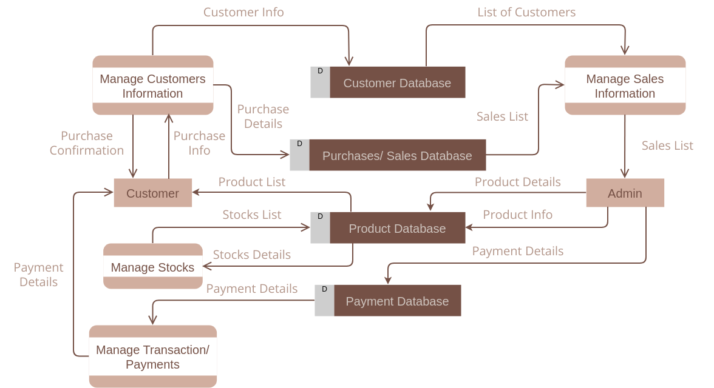

**5.2SOLUTION AND TECHNICAL ARCHITECTURE**

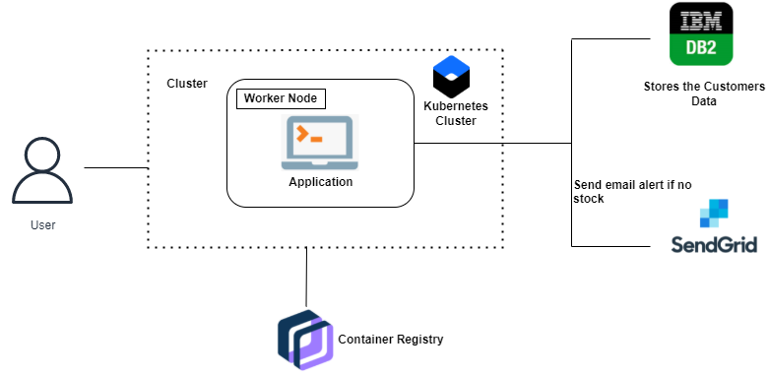

**5.3 USER STORIES**

As a store manager,

I want the available batch numbers and expiration dates that are currently valies for a product (are in use in the

countr) to auto-populate a drop-down list

So I don't have to manually enter the batch number for each transaction

As an administrator

I want to set-up the stock card to specify which fields display on the stock card, and the order of the fields

So that the stock card looks the same as the paper form used in country, without having to do software

development

As a store room manager,

I want my requisition automatically populated with current stock, stock consumed during the month, number of

stock out days, etc.

So that my requisition is accurate, and I save data entry time

As a store manager at a leaf node in system (no OpenLMIS lower),

I want to issue stock to somewhere else and update my stock count

So that commodities are distributed and my inventory is accurate

As a store manager,

I want my stock levels to be automatically updated with stock that I receive via informed push

So that my stock balance is accurate

As a store manager at any level,

I want to receive an ad-hoc shipment (one that hasn't been recorded as shipped in OpenLMIS, for example from a

private supplier, or from an inter-facility transfer)

So that my stock balances for all received goods are accurate

**6.PROJECT PLANNING AND SCHUDLING**

Project planning is important since it serves as a guide for all facets of the business process. It includes, among other things, the following:

* clarifies the methods that should be used
* Describes a few modes of communication.
* Recognizes who is in charge of each action.
* Describes a risk response mechanism for every imaginable event and risk.
* It has a system for tracking and monitoring progress.
* The pledge of partners is kept.

**6.1SPRINT PLANNING AND ESTIMATION**

A Sprint Planning meeting is held with the development team, management, and the Product Owner. The Product Owner is a representative of the customer or a contingent of customers. The Product Owner creates and prioritizes the Product Backlog. In the planning meeting, the Product Owner chooses which features are included in the next Sprint usually driven by highest business value and risk. The development team estimates the resource required for each desired feature via Planning Poker. Jointly, they determine a reasonable number of features to be included in the next Sprint based upon the team velocity. Once this set of features has been identified, no reprioritization takes place during the ensuing Sprint.

**6.2 SPRINT DELIVERY AND SCHEDULE**

The deliverables of a sprint aren’t as predictable as they are for other projects. Sprint participants have produced sketches and drawings, writing, photographs, comic strips, videos and fully coded working prototypes. The answer is whatever’s right to answer the problem.

Sprints also produce different deliverables for different audiences – the team, your organisation at large, the public – it really depends what you want to show people to help them understand your solution.

**6.3REPORTS FROM JIRA**

## Help employees help you with easy asset selection

As one of the first lines of interaction with your customer, the help center needs to offer a great end-user experience when it comes to getting support. Employees should be able to quickly find the assets associated with them so you can focus your time on the task at hand.

## Gain better visibility and inventory management for all your assets

After the ticket has been submitted, agents will immediately be able to view the issue and gain all the context they need about the asset that’s been selected

## Learn how to get started with Jira Service Desk asset management integrations

Getting started with our asset management integrations for Jira Service Desk Cloud is easy. Check out our **how-to video below** on setting up an integration.

**7.COADING AND SOLUTION**

**7.1 FEATURE 1**

### ****Improved, actionable inventory analysis****

As we said earlier, there are literally hundreds to thousands of data elements in inventory management systems.  What “out of the box” inventory management analyses are offered and do they fit your method of managing inventory?  What are the [key metrics that management can use](https://www.fcbco.com/blog/managing-inventory-metrics) to measure inventory, such as inventory turnover by product/SKU or gross margin return on investment (GMROI)?

The second point is how actionable is the data?  Given the sheer number of products and SKUs many companies have, merchandising and purchasing departments must find the time to address required actions while staying on top of their other responsibilities.  If there are data dashboards, how actionable are they?  Does the system point the purchasing agent or inventory manager to which products to take action on? For example, will the system flag potential stock outs; calculate recommended purchase orders; and candidates for overstock liquidation?  If not, will you have to develop these management tools?

**7.2 FEATURE 2**

**Configurability**

This feature allows a single system to be set up and configured for two different business entities/companies so that each has a different “look and feel” or personality.  In this way, the more comprehensive systems are successfully implemented across industries and merchandise without customization.

While all systems have configurability to some degree, what does it allow you to accomplish?  Examples of configuration include:

* A product with different colors and sizes may be configured in a way to show total product sales and stock on-hand by style or base product, as well as SKU.
* A role (group of users) or individual configuration table of users that allows for the set-up of data security functions within your organization for updating and viewing data.
* Flexibility for controlling different types of hardware or interfaces connected to the inventory management system.
* Adoption of your detailed expense accounting structure.

**8.TESTING**

**8.1** TEST CASES

8.2 USER ACCEPTANCE TESTING

9.RESULT

9.1 PERFORMANCE MATRICS

10.ADVANTAGES AND DISADVA**NTAGES**

**10.1 ADVANTAGES**

**It helps to maintain the right amount of stocks:**

**It saves time and money**

**It leads to a more organized warehouse**

**Improves efficiency and productivity**

**A well-structured inventory management system leads to improved customer retention**

**Schedule maintenance**

**Avoid lawsuits and regulatory fines**

**Increased information transparency**

**10.2 DISADVANTAGES**

**Bureaucracy**

**Impersonal touch**

**Increased space is need to hold the inventor**

**Complexity**

**High implementation costs**

**11.CONCLUSION**

As you can see the importance of inventory management is very serious, it is one of the most important aspects of any business. The aspect of this part of the business is whether or not you can satisfy the demand of your customers if you aren’t sure if you have all the materials availableto make the final product (Thibodeaux, 2014). Without Wheeled Coach©having the proper inventory management they would not be able to supply their customers with their ordered ambulance. And this product is what their entire business is based on, so it is of great importanceWhen they are choosing from the different types of programs or automated systems to help with keeping records accurate, Wheeled Coach©needs to keep in mind that the customer is not concerned with which materials are needed to complete the finished product, but the product is operating as promised based on the contract. This is why they need to make sure that any processes or programs that they do decide to use are going to be beneficial to their needs as well as the needs to service their customers (Warren, 2012). In addition, the plans for the maintenance of having proper inventory levels need to be in place and also adjusted when the company grows and as the business dictates (Thibodeaux, 2014). If Wheeled Coach©implements the new suggestions they will be on the right track to having a well established business.

**12.FUTURE SCOPE**

The scope of an inventory system can cover many needs, including valuing the inventory, measuring the change in inventory and planning for future inventory levels.

The value of the inventory at the end of each period provides a basis for financial reporting on the balance sheet.

Measuring the change in inventory allows the company to determine the cost of inventory sold during the period.

This allows the company to plan for future inventory needs.

**13.APPENDIX**

**13.1 SOURCE CODE**

**13.2 GITHUB & DEMO LINK**

**SOURCE CODE :**

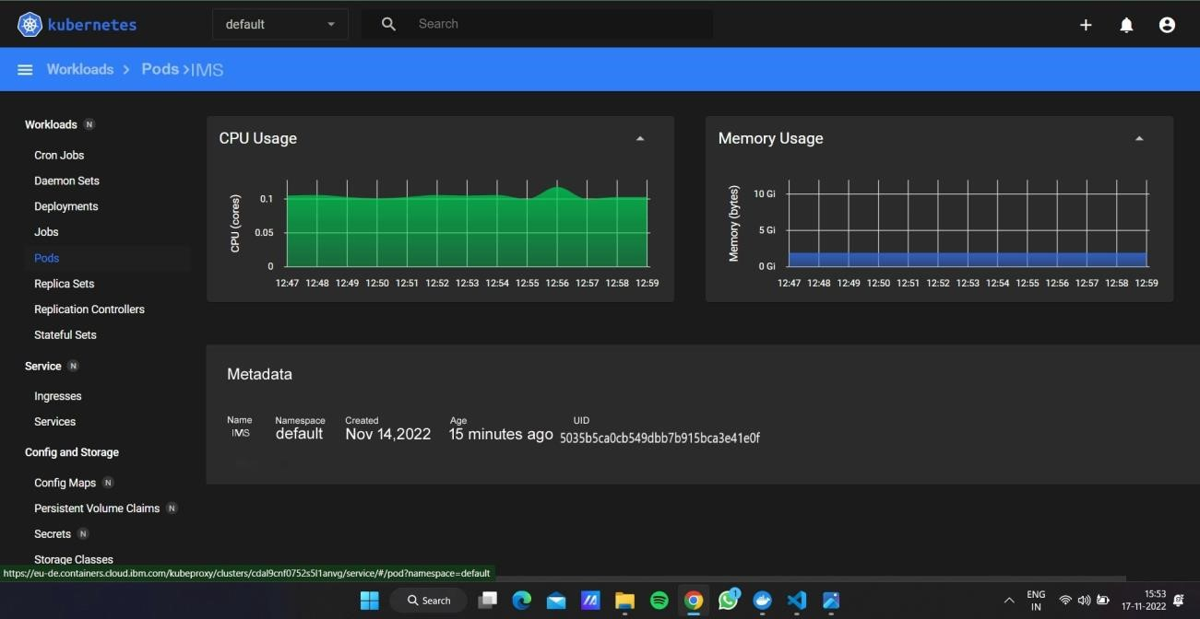

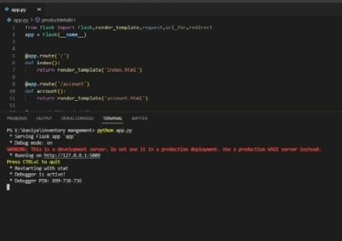



1. **RESULTS**

Car resale value prediction using cloud is developed and executed at the level of completed progress .

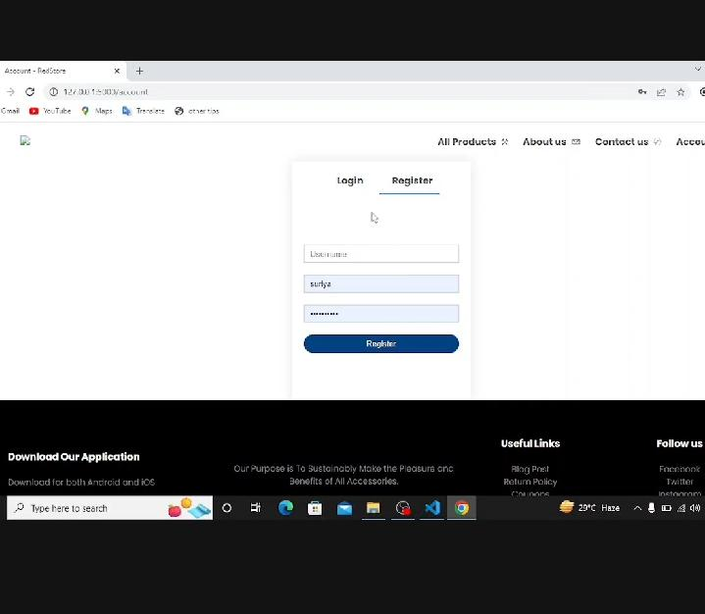

**CONCLUUSION:**

The increased prices of new cars and the financial incapability of the customers to buy them,

Used Car sales are on a global increase. Therefore, there is an urgent need for a Used Car Price Prediction system which effectively determines the worthiness of the car using a variety of features. The proposed system will help to determine the accurate price of used car price prediction. This paper compares 3 different algorithms for machine learning : Linear Regression, Lasso Regression and Ridge Regression

**APPENDIX:**

**Project demo link**

Our project runs on local host we can’t share or use the site

we attached source code through the link below